Celebrating Aboriginal
leaders and heroes
The South Australian Government has identified amongst other initiatives, ‘Pride in our history’ to celebrate the achievements and contributions of different Aboriginal leaders and heroes.
The statues and monuments at the centre of our towns and cities are almost exclusively about the history of those who colonised Australia, and of recent times are mostly about non-Aboriginal people.
It’s time for our statues and monuments to also celebrate Aboriginal Australia.
The Commissioner for Aboriginal Engagement, Dr Roger Thomas has been asked by the Minister for Aboriginal Affair, the Hon. Kyam Maher MLC to engage about this celebration with the Aboriginal community. This will involve the Commissioner getting your views about the idea and who you think could have their achievements recognised through a statue or monument.
To get the views of the South Australian Aboriginal community the Commissioner will commence a state-wide engagement with Aboriginal leaders and stakeholders.
He will have face to face conversations and have a questionnaire for community members to provide their views through Facebook, YourSAy and the Commissioner’s website. Written submissions can also be made and sent to the postal address below.
This engagement will close at 5pm 7 October 2022. Aboriginal community members can complete the on-line survey at:
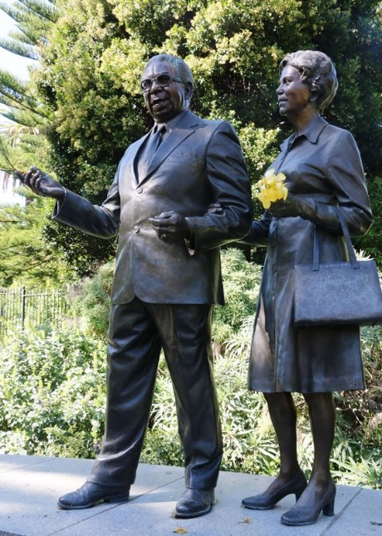
yoursay.sa.gov.au/aboriginal-statues-and-monuments
Or, contact the Office of the Commissioner for Aboriginal Engagement:
Free call: 1800 931 733
Email: CommissionerforAboriginalEngagement@sa.gov.au
Postal: GPO Box 464, Adelaide, SA 5001
Give your views  on statues &  monuments that  celebrate Aboriginal  South Australians | 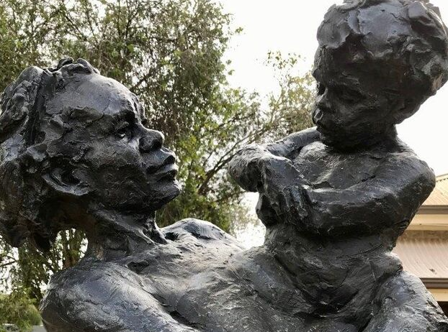

Do you identify as a person of Aboriginal and/or Torres Strait Islander descent? | YES | NO
Have you read the attached information about this idea? | YES | NO

Do you think it is a good idea to install new statues and monuments that celebrate South Australian Aboriginal leaders and heroes? | YES | MAYBE  NOT SURE | NO
If yes, are there any leaders and heroes from your community that could be recommended for consideration? | YES | MAYBE  NOT SURE | NO
Please tell us your thoughts or views about their contribution or achievements:

Is there a leader or hero that has contributed in South Australia that should be recognised? | YES | MAYBE  NOT SURE | NO
If yes, please provide their name:

Please tell us your thoughts or views about their contribution or achievements:

Please include any other comments or suggestions:

